|  |
| --- |
| Day-6 Morning Assignment  By  U.Joshna  [31-1-2022] |

|  |
| --- |
| program-1 |
| Create a simple program to declare ArrayList and assign some Values and find sum. |
| Code: |
| using System;  using System.Collections;  namespace Day6_Mrng_Assignment_ArrayList  {  internal class Program  {  static void Main(string[] args)  {  int sum = 0;  ArrayList data = new ArrayList();  data.Add(10);  data.Add(20);  data.Add(30);  data.Add(40);  data.Add(50);  {  sum = sum + Convert.ToInt32(data.Count);  }  Console.WriteLine($"Sum of data is {sum}");  Console.ReadLine();  }  }  } |
| Output: |
|  |
|  |
|  |

2.Research and find how the values of ArrayList are stored in the memory?

.The elements of an ArrayList are stored in a chunk of contiguous memory

.When that memory becomes full,a larger chunk of contiguous memory has to be allocated

.and the existing elements are copied into this new chunk

.We call this chunk the capacity of the ArrayList object

3.What are the Dis-advantages of ArrayList(Collections ArrayList)?

.The non-generic collection classes such as ArrayList,Stack,Queue,Hashtable,etc operate on the object data type

.If there is a Choice of assigning Wrong value we get runtime error

.Every time we unbox and do operation

|  |
| --- |
| Program-4 |
| Create a simple program to declare List<int> and assign some Values and find sum |
| Code: |
| using System.Collections.Generic;  using System.Linq;  namespace Day6_Mrng_Assignment__List  {  internal class Program  {  static void Main(string[] args)  {  List<int> intList = new List<int>() { 1, 2, 3, 4 };  int sum = intList.Aggregate((x, y) => x + y);  }  }  } |
| Output: |
|  |
|  |

**5.**In a tabular format write the differences between Collections and Generics?

1.namespace

2.Each element is of what type

3.do you need type casting here

4.Example – ArrayList, List<T>

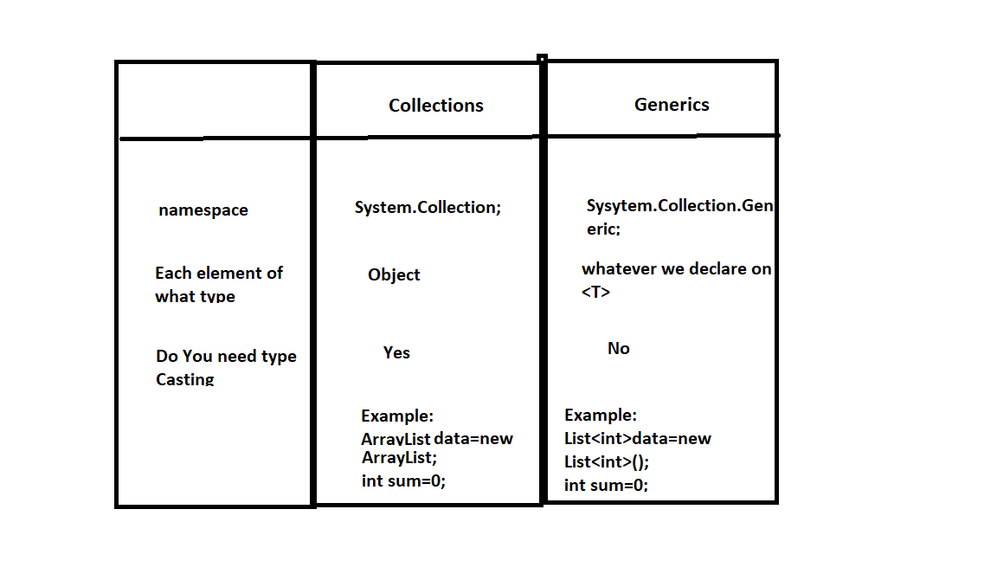

6.Research and find how the values of List<T> are stored in the memory?

.In a List<T>,the memory to store the value types is within the memory allocated for the System.Array(i.e,"Over Here").

In an ArrayList each element is just a reference to a boxed value type,

so the actual memory to store each value type is elsewhere on "The Heap",i.e,somewhere "Over There".

|  |
| --- |
| Program-8 |
| WACP to declare List<int> and read 5 values from user and find sum using  a.for loop  b.foreach loop  c.Lambda Expression |
| Code: |
| using System;  using System.Collections.Generic;  using System.Linq;  using System.Text;  using System.Threading.Tasks;  namespace Day6_Project  {  internal class Program  {  static void Main(string[] args)  {  int size, num, sum = 0, sum1 = 0, sum2 = 0;  List<int> data = new List<int>();  Console.Write("Enter list size: ");  size = Convert.ToInt32(Console.ReadLine());  for (int i = 0; i < size; i++)  {  Console.Write($"Enter {i} element: ");  data.Add(Convert.ToInt32(Console.ReadLine()));  }  //For Loop  for (int i = 0; i < data.Count; i++)  sum = sum + data[i];  //ForEach Loop  foreach (int n in data)  sum1 = sum1 + n;  //Lambda Expression  Console.WriteLine("\nFor Loop");  Console.WriteLine(sum);  Console.WriteLine("\nForEach Loop");  Console.WriteLine(sum1);  Console.WriteLine("\nLambda Expression");  Console.WriteLine(sum2);  Console.ReadLine();  }  }  } |
| Output: |
|  |
|  |

8.In a Tabular format write aa data types in C# and Write the respective alias name

|  |  |  |
| --- | --- | --- |
| SNO | Data Type | Alias Name |
| 1 | byte | Byte |
| 2 | ushort | Uint16 |
| 3 | uint | Uint32 |
| 4 | Ulong | Uint64 |
| 5 | sbyte | SByte |
| 6 | short | Int16 |
| 7 | int | Int32 |
| 8 | long | Int64 |
| 9 | float | Single |
| 10 | double | Double |
| 11 | decimal | Decimal |
| 12 | bool | Boolean |
| 13 | char | Char |
| 14 | string | String |